EXPERIMENT 02: Simulation of Density of States of Quantum Well Structure with Various Nanometer Thickness.

TEST CASE 1:
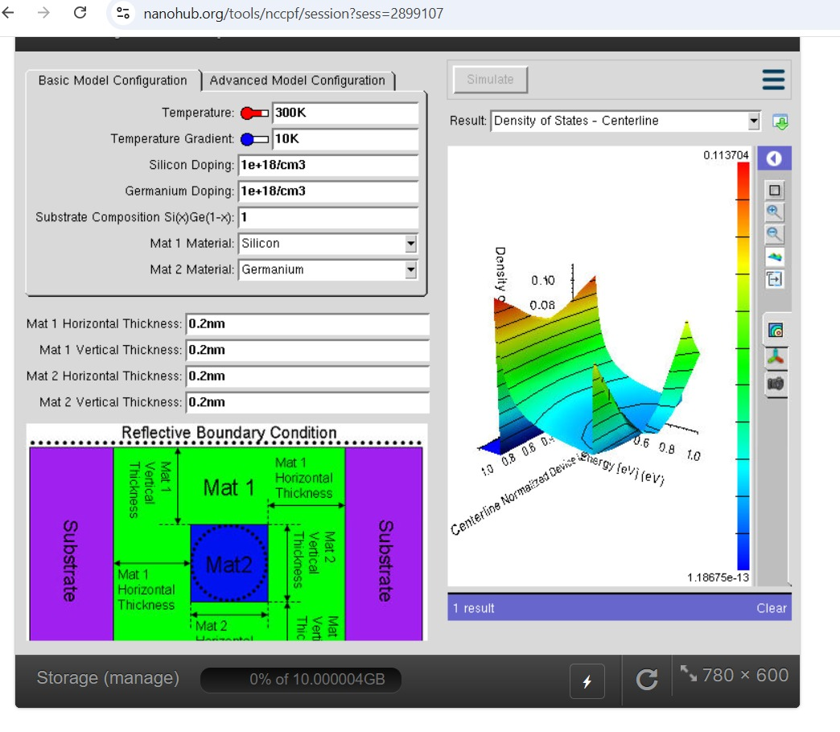
TEST CAE:02
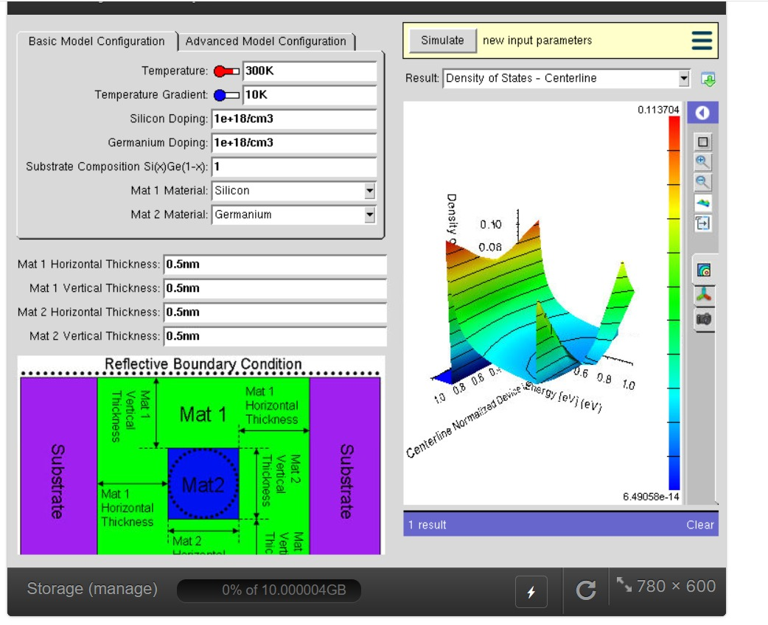

TEST CASE:03
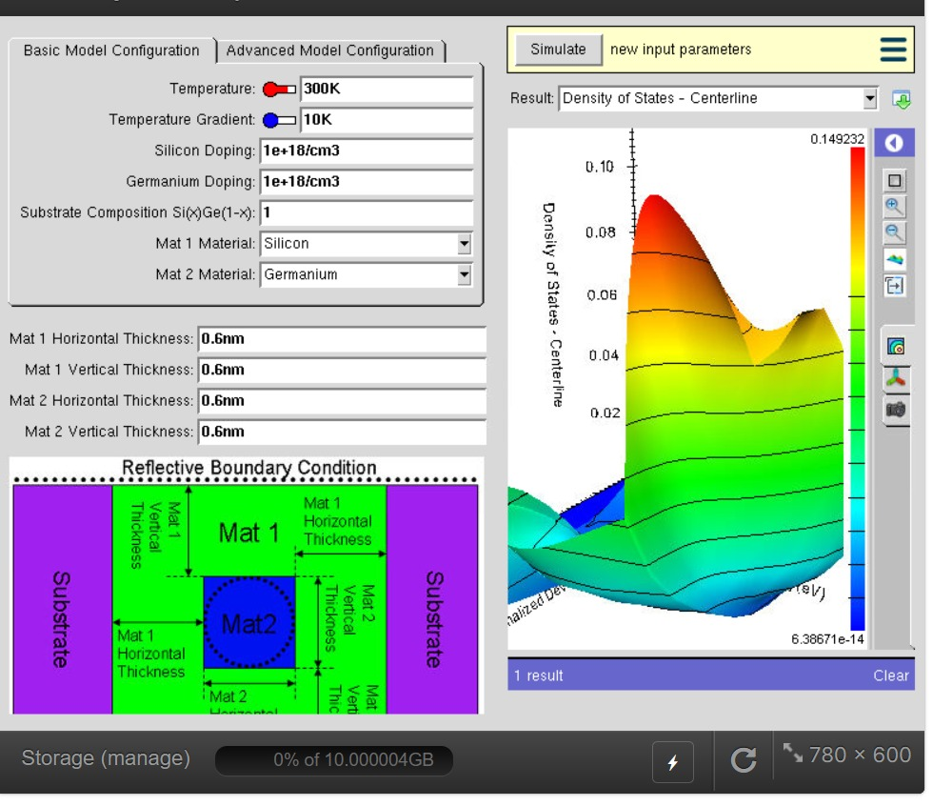
EXPERIMENT 3: Simulation of Energy States of Quantum Dot using NanoHub
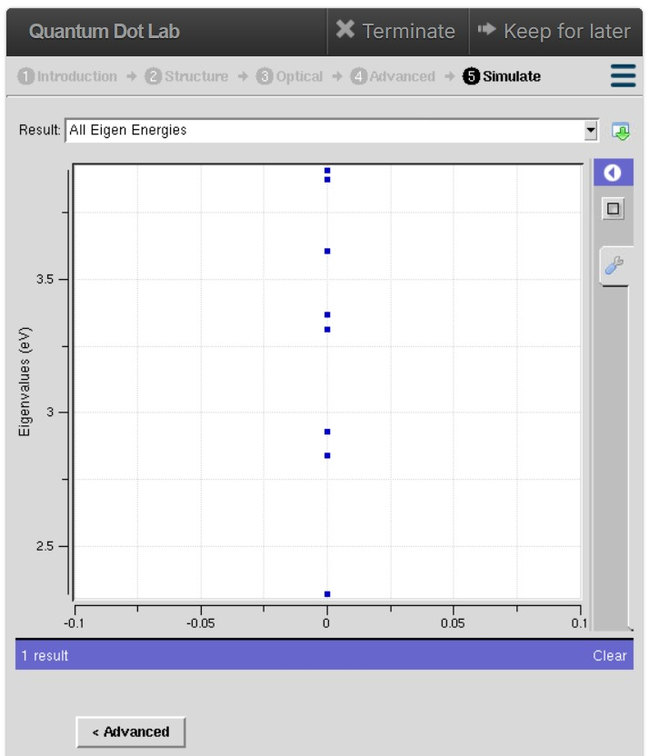

TEST CASE :2
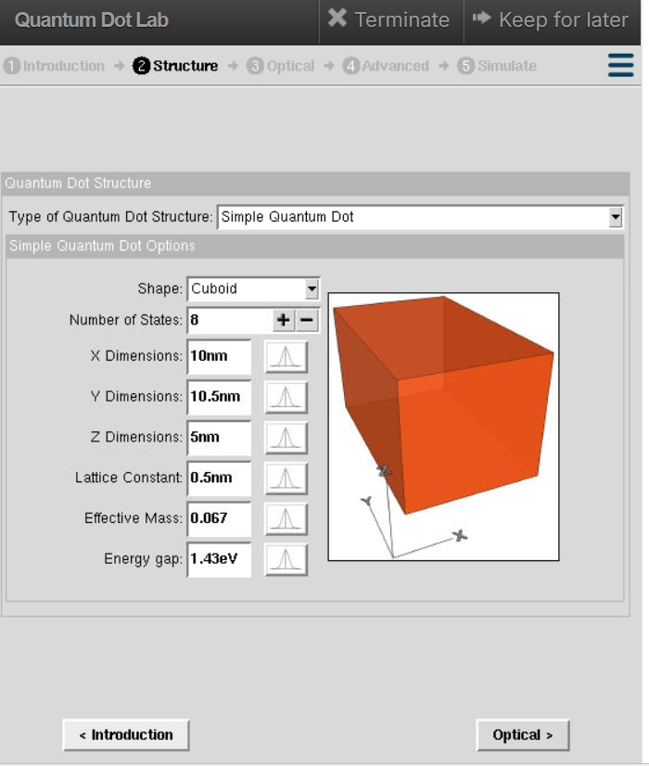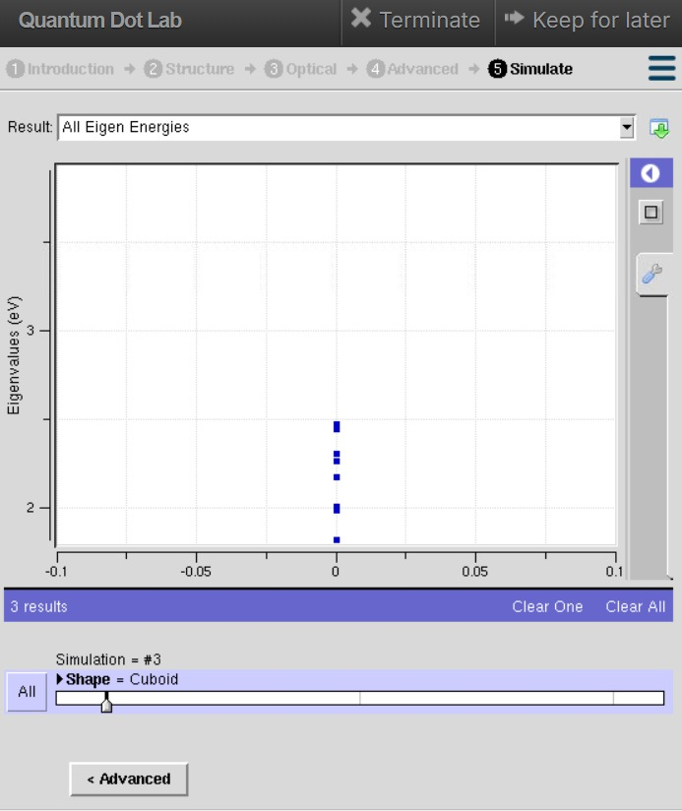

TEST CASE :3
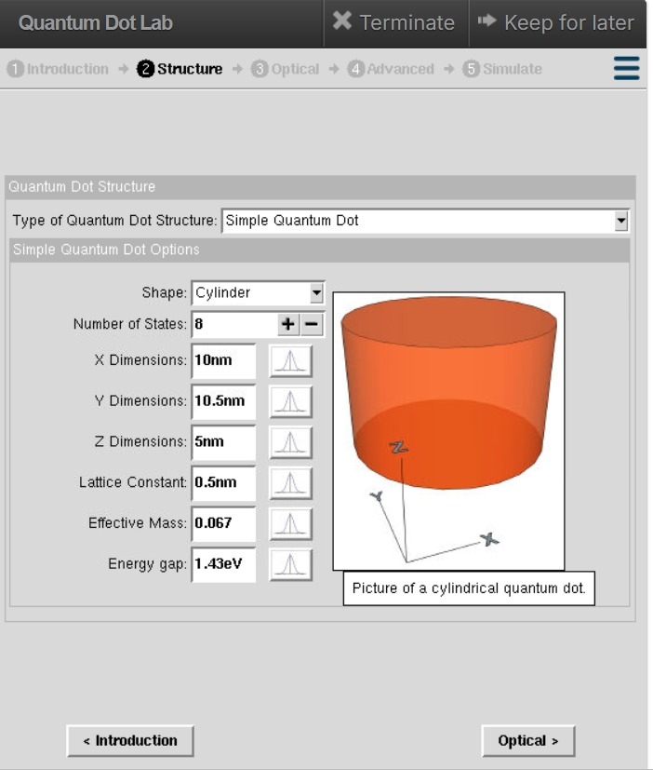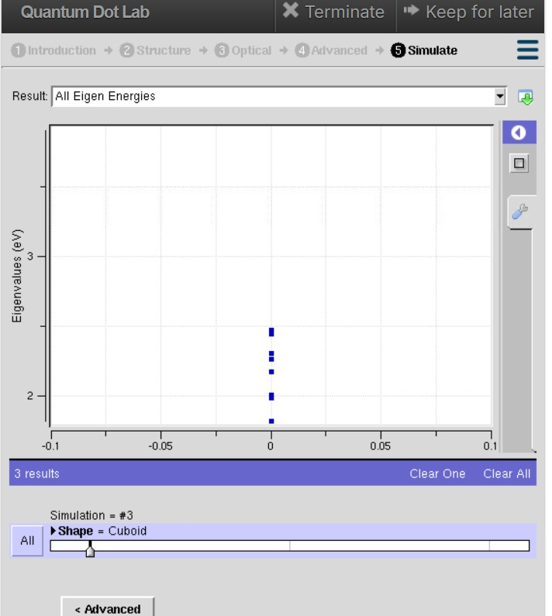

EXPERIMENT 4: Kronig Penney Model
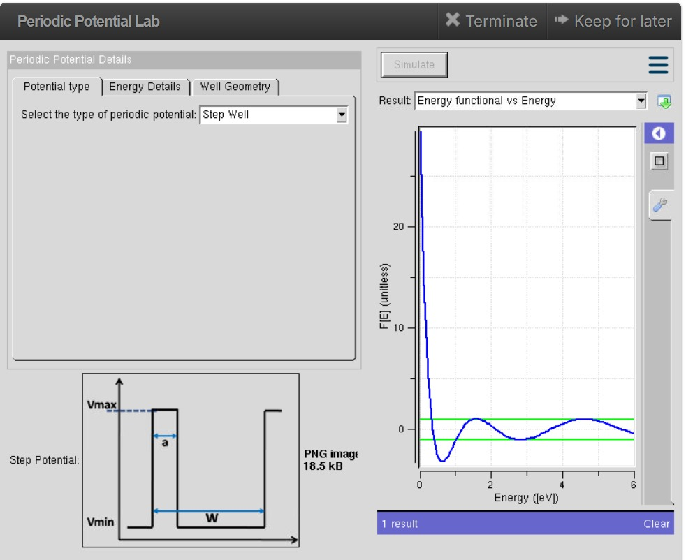
TEST CASE: 1

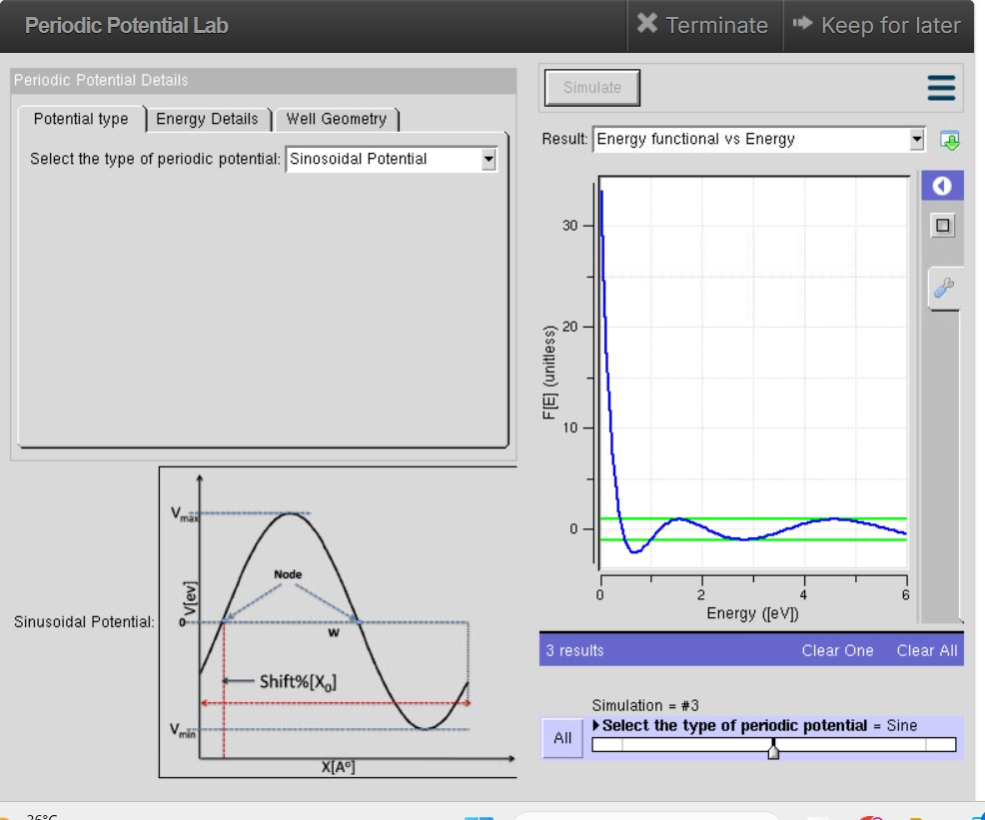
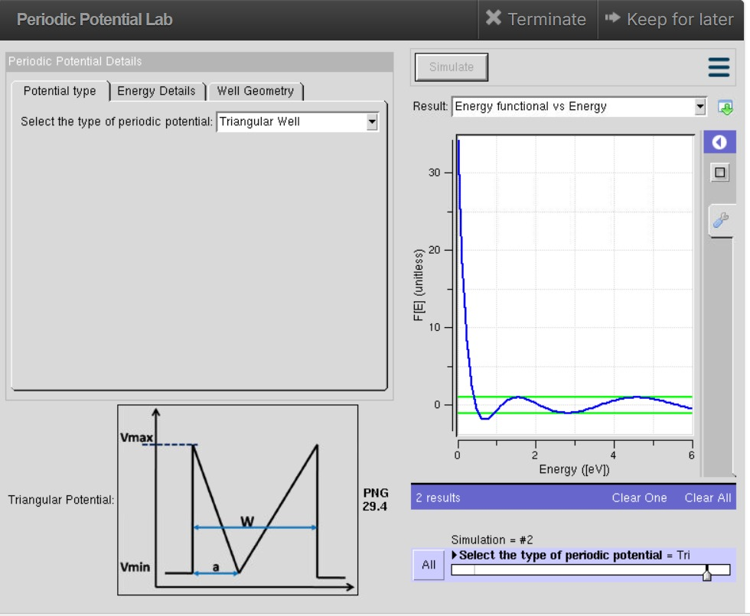

TEST CASE:02

TEST CASE :03

